Case 10-MEX-Aztec-Huitzilopochtli-Zultepec-War Mask-Human Sacrifice-300-100 BCE

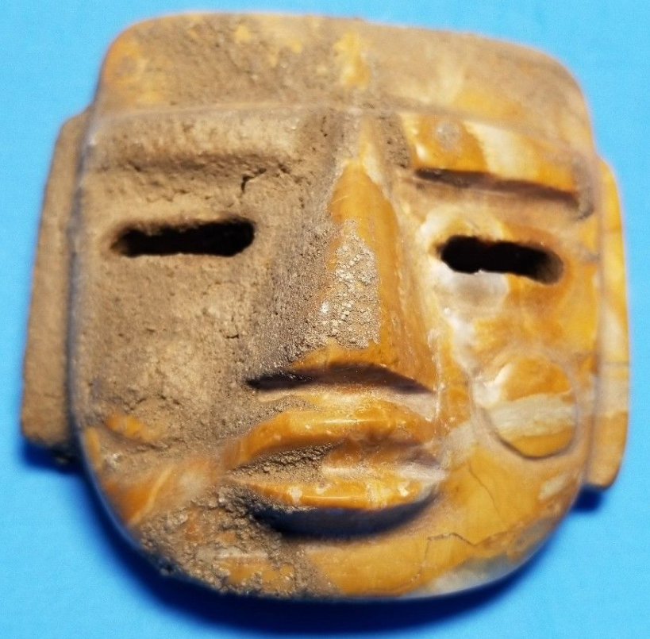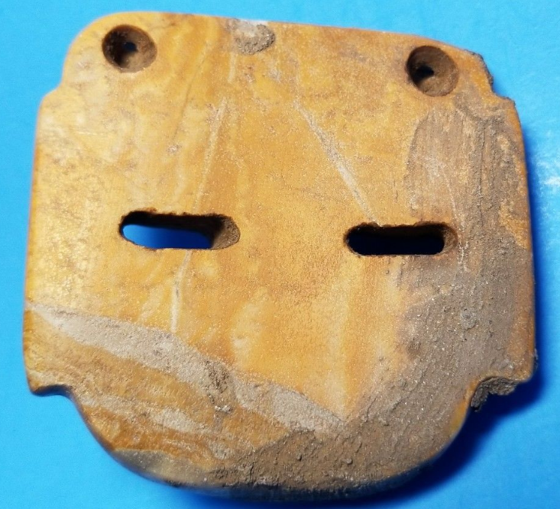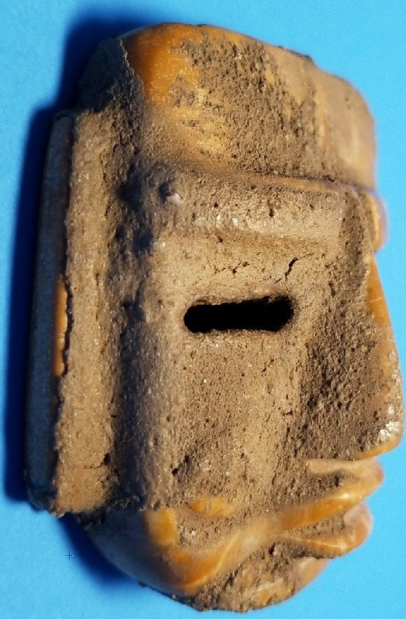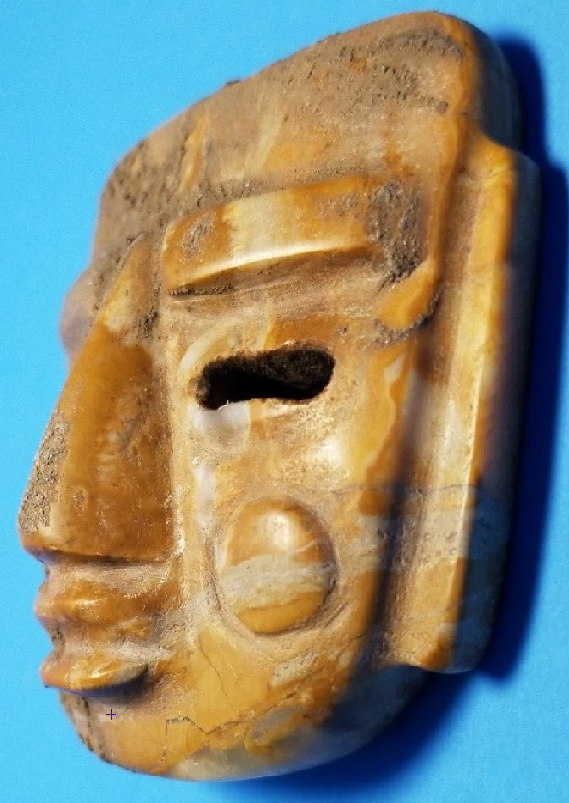

Figs. 1-4. Aztec-**Huitzilopochtli**-Zultepec City-Sun-War-Human Sacrifice-300-100 BCE

**Case no.: 9**

**Accession Number:**

**Formal Label:** Aztec-**Huitzilopochtli**-Zultepec City-Sun-War-Human Sacrifice-300-100 BCE

**Display Description:** This is a mask of Huitzilopochtli the Aztec deity of the sun which is indicated by the circular, packed scarification on his cheeks. The packing material used may be human ashes, and it is stuffed beneath the skin where it produces the circular effect seen on this mask. He is also the deity of war and human sacrifice and he is central to the story of this mask which is related to human sacrifice and cannibalism.

Initially, the Aztecs welcomed the Spaniards because they believed that they were their gods who had been predicted to return in 1519. Montezuma thought the Spaniarrds were “divine envoys” of the god Quetzalcoatl. The Spaniards led by Hernan Cortes murdered Cacamatzin (1483–1520), King of Texcoco, the second most important Aztec city. Then Cortez took Montezuma hostage so he could control the Aztec empire through him (Martinez 2006).

Warriors of Zultepec, an Aztec town of 5,000 people (now Calpulalpan in the state of Tlaxcala, 100 miles east of Mexico City) heard of the murder of Cacamatzin and the capture of Montezuma and resolved to capture a caravan of Spanish conquistadors in retaliation as they traveled to Tenochtitlan later in 1520.

Aztecs had ritual sacrifice for 18 months in one cycle in which victims would be painted and placed on a slab where their hearts would be removed and held up as offerings to the Sun.  The body would be thrown down the stairs of Huitzilopochtli’s temple. At Zultepec the Aztecs imprisoned the Spanish caravansary in cages and tortured, sacrificed and partially ate the prisoners, which is indicated by knife cuts and teeth marks on the bones that show which ones had meat stripped off to be eaten. Recovery of human bones have enabled the identification of about 550 victims, who probably had their hearts ripped out, their bones boiled and scraped clean. This mask was probably witness to this scene. "It was a continuous sacrifice over six months. While the prisoners were listening to their companions being sacrificed, the next ones were being selected". "This is the first place that has so much evidence there was resistance to the conquest," said archeologist Enrique Martinez, director of the dig here. "It shows it wasn't all submission” (Martinez 2006).

Upon hearing of the massacre, Cortes renamed the town Tecuaque -- "where people were eaten" in the indigenous Nahuatl language -- and sent an army to destroy the city. When they heard the Spanish were coming, the Zultepec Aztecs threw their victims' possessions down wells, unwittingly preserving buttons and jewelry (Martinez 2006).

**LC Classification:**

**Date or Time Horizon:** 1520

**Geographical Area:** Zultepec City (modern Calpulalpan)

**Map:**

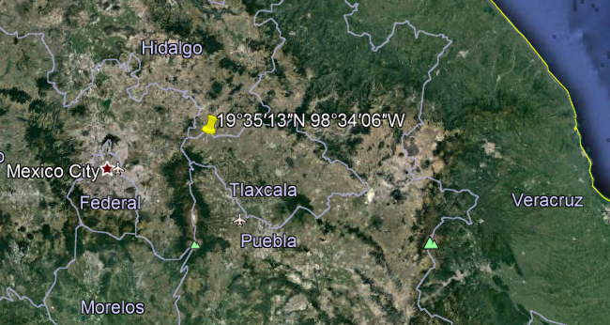

**GPS coordinates:** 19°35′13″N 98°34′06″W

**Cultural Affiliation:** Aztec

**Media:** jade

**Dimensions:** H 2 ½ in, W 2 ½ in

**Weight:**

**Condition: original**

**Provenance:** Zultepec City

**Discussion:**

[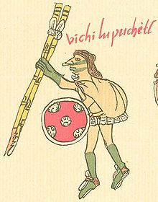](https://en.wikipedia.org/wiki/File:Huitzilopochtli_human.jpg)

Huitzilopochtli in human form in the [*Codex Telleriano-Remensis*](https://en.wikipedia.org/wiki/Codex_Telleriano-Remensis)*.* Probably this was the way the Aztec warriors appeared as agents *of* Huitzilopochtli as they fought the Spanish Conquistadores.

 

**The temple of** Huitzilopochtli **in Texcoco (**de La Harpe 1780, **vol. 11, p. 241, plate 57).**

**References:**

de La Harpe, Jean-François. 1780. Abrégé de l'Histoire générale des voyages : contenant ce qu'il y a de plus remarquable, de plus utile & de mieux avéré dans les pays où les voyageurs ont pénétre : les mœurs des habitans, les religion, les usages, arts & sciences, commerce, manufactures : enrichie de cartes géographiques & de figures. Paris : Hôtel de Thou.

Martinez, Enrique. 2006. “Aztecs Tortured, Ate Spaniards, Bones Show

Evidence of capture and rituals is unearthed at a site near Mexico City,” *The Los Angeles Times*, Aug. 26.